NAME :- MUHAMMAD AHMED
ROLE :- GROUP LEAD
TOOL USED :- WIRESHARK
INTRO :- I am the Group Lead for this project. I used Wireshark to capture and analyze network traffic, and based on that, I defined 5 network detection rules for a healthcare clinic, listed below.
RULES :-
*Rule 1: Plaintext Login Credentials*
- Detection: Login credentials (username/password) sent over unencrypted HTTP instead of HTTPS
- Risk: Credentials can be intercepted by anyone monitoring the network
- Response: Force the system to use HTTPS/TLS, reset the exposed credentials, notify IT

*Rule 2: Brute-Force Login Attempts*
- Detection: Multiple repeated login attempts from the same IP address in a short time
- Risk: Indicates someone trying to guess a password or break into an account
- Response: Block the source IP, lock the affected account, alert the security team

*Rule 3: Off-Hours System Access*
- Detection: Login to the EHR/clinic system outside normal working hours
- Risk: May indicate stolen credentials or insider misuse
- Response: Confirm with the user if the access was legitimate; suspend the account if not

*Rule 4: Unusual Outbound Traffic*
- Detection: Data being sent to an unfamiliar or high-risk destination IP/country
- Risk: Could indicate data exfiltration or malware communicating with an external server
- Response: Block the connection, scan the device for malware, investigate the source
*Rule 5: Medical Device Communicating on an Unexpected Port*- Detection: A medical device (e.g., infusion pump, imaging system) sending traffic on a port it normally shouldn't use
- Risk: May indicate the device has been compromised
- Response: Isolate the device from the network, notify IT/device vendor immediately
SAMPLE LOG REVIEW :-
TIME | SOURCE IP | DESTINATION | ALERT TYPE | STATUS
11:33 PM | 192.168.100.15 | 157.240.227.60 | Normal TLS traffic | OK
11:35 PM | 192.168.100.15 | 4.150.223.96 | Normal TCP traffic | OK
2:15 AM | 192.168.100.15 | EHR System | Off-hours access attempt | ⚠ Flagged
10:20 AM | Unknown IP | Rare country server | Unusual outbound traffic | ⚠ Flagged

WIRESHARK SCREENSHOT :-
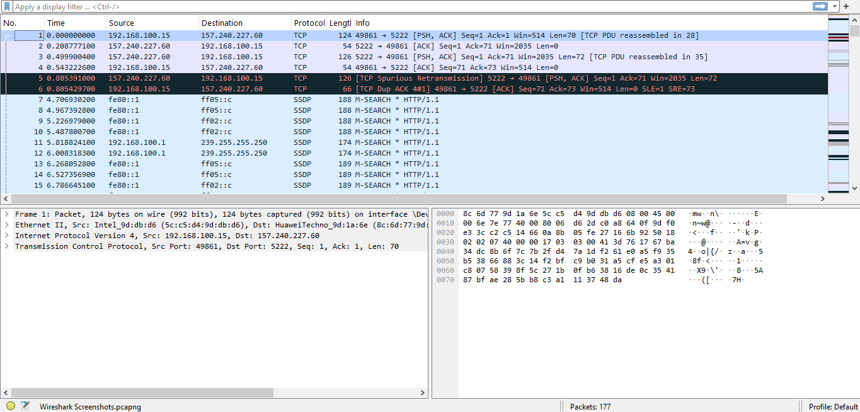

CONCLUSION :-
In this task, I used Wireshark to capture and analyze live network traffic. Based on this, I defined 5 detection rules covering common security risks in a healthcare clinic — plaintext credentials, brute-force login attempts, off-hours access, unusual outbound traffic, and compromised medical devices. I also documented response steps for each alert type and created a sample log-review report to show how these rules would appear in practice. These detection rules and monitoring practices will help the clinic identify security threats early and respond quickly, keeping patient data and critical systems safe.

